PDT-2676 - Payment Reverse TO-BE
Jira: PDT-2676
Created: 17 April 2026
Updated: 23 April 2026

After the change, Payment Reverse becomes a distribution operation. Instead of simply canceling the payment, the user can redirect the reversed amount to one or more customers, and optionally allocate specific amounts to specific liabilities.
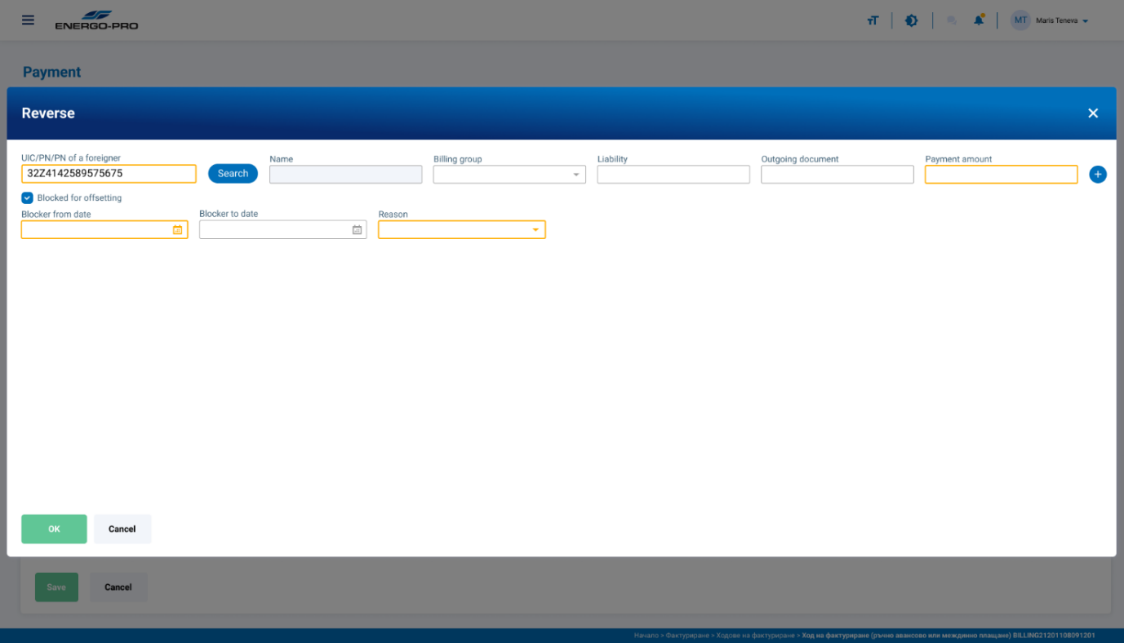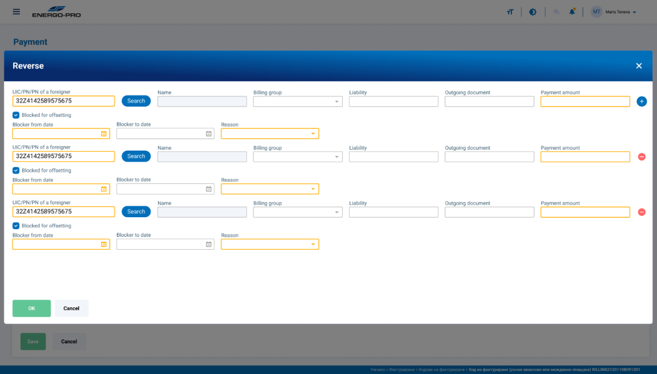

Field Filling Process

Find the whole process in the TO BE Tab of the attached diagram.

- User opens Reverse on an existing payment.
- System shows the reverse form with:
  - original payment amount (read-only control total),
  - first allocation row already visible,
  - Add (+) button enabled,
  - Delete (X) disabled on the first row.
Reverse form fields for each row:
ld | Mandatory? | Value Type | Behavior
Customer | Mandatory | SINGLE_SELECT_DROPDOWN (searchable) | User selects target customer
Billing Group | Optional | SINGLE_SELECT_DROPDOWN | Skipped/disabled if selected liability has no billing group; otherwise selectable/filtering context
Liability | Optional | SINGLE_SELECT_DROPDOWN (searchable) | User may select one liability; outgoing document auto-populates from selected liability
Outgoing Document | Auto-populated | READ_ONLY_TEXT | Auto-filled from selected liability’s outgoing document; blank if no liability selected
Amount | Conditional | DECIMAL_NUMBER_INPUT (currency) | Optional for single-customer reverse; mandatory (>0) for multi-customer
Blocked for offsetting | Optional | CHECKBOX | Per-row toggle
Blocked Date From | Optional | DATE_PICKER | Enabled only when “Blocked for offsetting” is checked
Blocked Date To | Optional | DATE_PICKER | Enabled only when “Blocked for offsetting” is checked
Blocking Reason | Optional | TEXT_AREA (or TEXT_INPUT) | Enabled only when “Blocked for offsetting” is checked
Plus Button (Add) | Optional | ICON_BUTTON | Always enabled; adds new allocation row
X Button (Delete) | Optional | ICON_BUTTON | Enabled for rows after the first one; disabled for first row

- In the first row, user selects Customer (mandatory).
- User may select Liability (optional).
- If liability is selected:
  - system auto-fills Outgoing Document (read-only),
  - system handles Billing Group behavior:
    - if liability has billing group → set/filter billing group,
    - if liability has no billing group → billing group is skipped/disabled.
- User enters Amount:
  - if only one row exists, amount is optional (system may default to full original amount),
  - if multiple rows exist, amount is mandatory in each row.
- User may check Blocked for offsetting:
  - if checked, system enables:
    - Blocked Date From,
    - Blocked Date To,
    - Blocking Reason.
  - if unchecked, those fields stay disabled and ignored.
- User can click + Add to create additional rows.
  - each new row repeats the same field logic,
  - Delete (X) is enabled for non-first rows.
- User clicks Submit/Confirm.
- System runs validations:
  - field-level validations first,
  - then total-balance validation,
  - then cross-field/cross-row consistency checks.
- If all validations pass, reverse continues to processing.
- If any validation fails, submission is blocked and errors are shown.

Validation and Error Messages

A) Field-level errors
- Customer missing
  - Message: Customer is required.
- Amount missing (multi-row case)
  - Message: Amount is required when multiple customers are selected.
- Amount is zero or negative
  - Message: Amount must be greater than 0.
- Invalid amount format
  - Message: Enter a valid numeric amount.
- Blocked date range invalid
  - Message: Blocked Date To must be the same as or later than Blocked Date From.
- Blocked fields incomplete when blocked is checked
  - Message: Please complete blocking details (From/To/Reason).

B) Cross-field / row-consistency errors
- Liability does not belong to selected customer
  - Message: Selected liability does not belong to the selected customer.
- Billing group conflicts with selected liability
  - Message: Selected billing group does not match the liability.
- Duplicate invalid targeting
  - The same liability cannot be selected in more than one allocation row within the same reverse operation. When the user clicks Save, the system checks all rows; if a duplicate liability is found, the save action is blocked and inline validation is shown on the affected rows with the message: "This liability is selected in more than one allocation row. Please keep each liability in only one row."

C) Form-level total validation
- Allocation sum mismatch
  - Message: Total allocated amount must equal original payment amount.
  - Optional detailed message: Allocated total is {X}; original payment is {Y}.

D) Action-control behavior messages
- On first row delete attempt:
  - At least one allocation row is required.
- On submit with no valid rows:
  - Please complete at least one valid allocation row.
Reversing process
Once validated:
- The original payment is marked as REVERSED (same as now).
- A reversal record of Payment with negative amount is created (same as now).
- Allocation rows are processed in sequential order (Row 1, then Row 2, then Row 3, etc.).

Apply row outcome by row type
A) Customer Only
- System runs standard automatic offsetting against customer's outstanding liabilities (oldest due first).
- If liabilities exist: allocated amount is consumed in standard order.
- If no liabilities exist: create customer receivable for full row amount.
- If only partial liabilities exist: consume liabilities first, receivable for remaining amount.
B) Billing Group + Customer
- System runs automatic offsetting only within that customer's selected billing group.
- If matching liabilities exist: offset in standard order within that billing group.
- If no matching liabilities in that billing group: create receivable for full row amount.
- If matching liabilities are insufficient: receivable for remaining amount.
C) Customer + Liability
- System first creates direct allocation to selected liability.
- If row amount <= selected liability outstanding: fully consume row on selected liability.
- If row amount > selected liability outstanding:
  - fully consume selected liability,
  - distribute excess through customer's remaining liabilities in standard order,
  - if excess still remains, create receivable for final remainder.
D) All Fields (Customer + Billing Group + Liability)
- Same allocation logic as Customer + Liability.
- Billing group is contextual confirmation only (does not change direct-liability-first behavior).
- Excess handling remains: other liabilities first, then receivable.
Cross-Row Processing Rules
- Earlier rows affect later rows (remaining balances are updated in sequence).
- A liability fully covered in earlier rows is not available as outstanding in later rows.
- A liability partially covered earlier can still receive valid remaining allocation later (if selected and still open).
- System never over-allocates beyond available outstanding amounts; excess always follows fallback chain.

Exception / Failure Paths
Transaction failure (any row or system error)
- Entire reverse is canceled.
- No partial financial effect is persisted.
- User message (ENG):
"An error occurred while processing the allocation. The operation has been cancelled. Please try again."
- User message (BG):
Runtime data-change scenarios (after Save, before/during processing)
System should fail safely (rollback + error) when:
- selected liability became closed/fully paid by another operation,
- selected liability no longer belongs to selected customer,
- selected billing group no longer valid for that liability/customer,
- accounting constraints block posting (period/rule conflict),
- concurrency conflict occurs on balances.

Additional Functional Change
Direct Liability Allocation Process
Today, reverse allocation is mostly customer-driven (system decides where to offset).
With this change, each row can explicitly say: “Apply this amount to this exact liability.”
That creates a new primary path:
- Row has customer + liability (+ optional BG)
-> system does direct offset to selected liability first
-> only then uses fallback logic for any remainder.
Step-by-step behavior
- User selects row fields:
  - Customer (required)
  - Liability (selected explicitly)
  - Amount
  - Optional BG (context/validation)
- On Save, system validates:
  - liability belongs to selected customer,
  - (if BG present) BG is compatible,
  - same liability not duplicated in another row.
- During processing, for that row:
  - Read selected liability outstanding amount.
  - Apply row amount to that liability first.
- If row amount is fully consumed by selected liability:
  - create payment-to-liability allocation record,
  - row is done.
- If row amount exceeds selected liability outstanding:
  - fully cover selected liability,
  - send remaining amount to fallback chain:
    - customer’s remaining open liabilities (standard order),
    - if none left -> create receivable for remainder.
- Persist row results and continue with next row in sequence.

Key rules
- Direct liability allocation has higher priority than automatic offsetting for that row.
- Billing Group does not override selected liability; it is context/validation when liability is already explicit.
- Duplicate liability across rows is blocked at Save.
- Entire operation remains transactional (failure in any row rolls back all rows).
Example
- Selected liability outstanding: 50
- Row amount: 100
- Result:
  - 50 directly allocated to selected liability
  - 50 -> other liabilities (if any), otherwise receivable

Example Scenarios

Case 1 — Single Customer, No Liability Selected (Automatic Offsetting)
Setup: Original payment: 300 for Customer A. Customer A has Liability 1 (outstanding 120) and Liability 2 (outstanding 180).
Row | Customer | Billing Group | Liability | Payment Amount
1 | Customer A | - | - | 300
System behavior:
- Amount is auto-assigned (single customer, amount left empty → full 300).
- Standard automatic offsetting runs: Liability 1 is offset by 120, Liability 2 is offset by 180.
- Total covered: 120 + 180 = 300. No receivable created. Operation completes.

Case 2 — Single Customer, Liability Selected, Partial Coverage
Setup: Original payment: 500 for Customer A. Customer A has Liability 1 (outstanding 200) and Liability 2 (outstanding 150).
Row | Customer | Billing Group | Liability | Payment Amount
1 | Customer A | - | Liability 1 | (auto: 500)
System behavior:
- 200 is allocated directly to Liability 1 (fully covers it).
- Remaining 300: standard offsetting runs → Liability 2 offset by 150.
- Remaining 150: no more liabilities → receivable of 150 created for Customer A.

Case 3 — Multi-Customer, Automatic Last Row Calculation
Setup: Original payment: 1,000 for Customer A. Customer B has Liability 3 (outstanding 400). Customer C has no liabilities.
Row | Customer | Billing Group | Liability | Payment Amount
1 | Customer B | - | Liability 3 | 400
2 | Customer C | - | - | (auto-calculated: 600)
System behavior:
- User enters 400 in Row 1. System calculates Row 2 amount as 1,000 − 400 = 600.
- Row 1: 400 allocated against Liability 3 (Customer B) — fully offset.
- Row 2: Customer C has no liabilities → receivable of 600 created for Customer C.

Case 4 — Customer + Liability from Different Billing Groups in Multiple Rows
Setup: Original payment: 1,000 for Customer A. Customer A has:
- Liability 1 (BG-01, outstanding 600)
- Liability 2 (BG-02, outstanding 400)
Row | Customer | Billing Group | Liability | Payment Amount
1 | Customer A | BG-01 (auto from Liability 1) | Liability 1 | 600
2 | Customer A | BG-02 (auto from Liability 2) | Liability 2 | 400
System behavior:
- Selecting liabilities from different billing groups in separate rows is allowed.
- Row 1: Direct allocation of 600 against Liability 1. Fully offset.
- Row 2: Direct allocation of 400 against Liability 2. Fully offset.
- 600 + 400 = 1,000. Balances. Operation completes.

Case 5 — Mixed: Some Rows with Liability, Some Without
Setup: Original payment: 900 for Customer A. Customer A has Liability 1 (outstanding 300). Customer B has Liability 2 (outstanding 200) and Liability 3 (outstanding 400).
Row | Customer | Billing Group | Liability | Payment Amount
1 | Customer A | - | Liability 1 | 300
2 | Customer B | - | - | 600
System behavior:
- Row 1: Direct allocation of 300 against Liability 1 (Customer A) — fully offset.
- Row 2: No liability selected → automatic offsetting for Customer B. Liability 2 offset by 200, Liability 3 offset by 400. Total: 600. Exact match.
- 300 + 600 = 900. Balances. Operation completes.

Case 6 — Liability with No Billing Group
Setup: Original payment: 250 for Customer A. Customer B has Liability 7 (no billing group, outstanding 250).
Row | Customer | Billing Group | Liability | Payment Amount
1 | Customer B | (empty, auto — liability has no BG) | Liability 7 | (auto: 250)
System behavior:
- User selects Customer B, then selects Liability 7.
- Liability 7 has no billing group → Billing Group field stays empty (not auto-populated).
- 250 is allocated directly against Liability 7. Fully offset.
- Operation completes.

